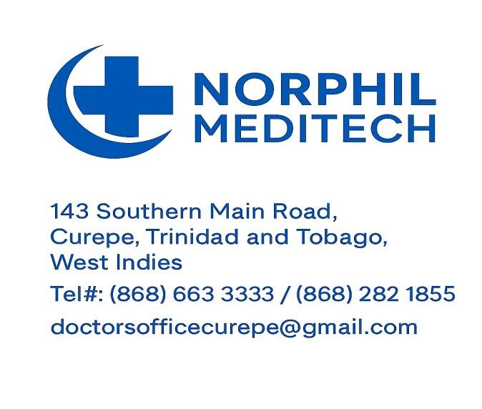
Practice Overview
Norphil Meditech is a comprehensive primary care medical practice led by Dr. Gregory Athekame, MBBS -- a dedicated and compassionate physician with more than twelve (12) years of experience in general and family medicine.

The practice is committed to delivering accessible, patient-centred healthcare through a combination of in-office consultations, house calls, and workplace visits. Dr. Athekame’s approach focuses on preventive medicine, early diagnosis, and personalized treatment plans for individuals and corporate clients alike.

Key Services
- General & Preventive Care
Full medical examinations and wellness screenings
Preventive health counselling
Medical certification for Food Handler’s Badge and occupational fitness assessments
- Chronic Disease Management
Ongoing care for patients with diabetes, hypertension, high cholesterol, and asthma
Regular monitoring, medication review, and lifestyle/nutritional guidance

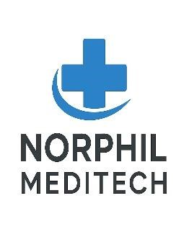
__________________________________________________________________________
- Advanced Limb Salvaging & Specialized Diabetic Wound Care
- Comprehensive assessment and management of diabetic foot ulcers, pressure injuries, venous ulcers, and other chronic wounds.
- Evidence-based wound care, infection management, off-loading strategies, and ongoing wound surveillance.
- Limb preservation (limb salvage) through early diagnosis, timely intervention, and coordinated multidisciplinary care to reduce the risk of lower-extremity amputation.
- Dr. Gregory Athekame has successfully preserved the limbs of numerous patients with advanced diabetic foot disease who had previously been advised that amputation was necessary, where clinically appropriate.
4. Acute Illness & Injury Care
Diagnosis and management of common medical conditions such as colds, flu, infections, and minor injuries
- Minor Surgical Procedures
- Wound suturing and laceration repair
- Incision and drainage of abscesses
- Excision of skin tags, sebaceous cysts, and other benign skin lesions
- Partial and complete nail avulsion for ingrown toenails
- Wound debridement for diabetic foot ulcers and chronic wounds
- Foreign body removal
- Suture and staple removal
- Sterile dressing of acute and chronic wounds

- Laboratory Services
On-site laboratory testing for a wide range of blood tests
External lab partnerships for specialized investigations
Comprehensive and discounted medical packages available for in-office patients, and corporate health screening
7. Home & Office Visits
- House Calls: At-home medical visits for patients requiring care in the comfort of their homes. Medical consultations for patients requiring care in the comfort and convenience of their homes.
- Office Visits: Workplace consultations for staff members and corporate clients, including executive health assessments and employee wellness services.
- Intravenous (IV) Therapy: Administration of prescribed intravenous fluids, medications, vitamins, and antibiotics, where clinically indicated, in the home or workplace setting.
- Follow-up assessments, chronic disease monitoring, post-hospitalization care, and medication management.
- Suitable for elderly patients, individuals with limited mobility, and patients recovering from illness or surgery.
- Workplace Visits: Workplace consultations for staff members and corporate clients. Suitable for executive checkups, follow-ups, and employee wellness programs
9. Diagnostic Imaging
Mobile Ultrasound Services:
A certified mobile ultrasound technician is available on call for home and office visits, providing convenient on-site imaging for diagnostic evaluations.
10. Patient Education
Guidance on preventive health, treatment options, and disease management



Our Philosophy
Patient-Centred Care: Listening, understanding, and tailoring management to each individual
Holistic Health: Addressing the physical, emotional, and lifestyle factors influencing wellbeing
Quality and Integrity: Maintaining high clinical standards and ethical practice
Accessibility: Extending care beyond the clinic through house calls and corporate site visits

_____________________________________________________________________________________

Staff
Medical Practitioner & Director
Dr. Gregory Athekame, MBBS (UWI)
Medical Board of Trinidad & Tobago Registration No. A-386
Over 12 years' experience in General and Family Medicine, with a special interest in chronic disease
Practice Communications Manager/ Healthcare Customer Relations Specialist/Patient Advocate
Giselle McIntyre, Advance Dip. (Media & Mass Comms.), B.A. (Communication Studies), M.Sc. (International Relations) (UWI)
Florence Academy, London
- Basic Life Support (BLS) – Theory
- Adult Medical Support & Protection
- Dementia Awareness – Level 1
On-call Ultrasound Technologist/Sonographer
Alicia Daniel, BSc (Radiography) Adv. Dip (Ultrasound)


___________________________________________________________ Hours of Operation
- Monday – Friday: 9:300 a.m. – 5:00 p.m. Saturday: 9:00 a.m. – 2:00 p.m.
Sundays & Public Holidays: By special appointment only

- Flexible availability for urgent or emergency medical needs.
- On-call services for prompt response during or outside office hours.
- House calls and workplace visits to ensure minimal disruption to your team.
- Reliable, professional care tailored to meet corporate health requirements.

Insurance Accepted
Beacon • Guardian Group • Maritime • CLICO • Sagicor • Med Access • Pan American
- RBC • Tatil • UNIMED • WASA Estate Police & Daily Paid…et al

_______________________________ __________________________________________

Official Stamp Signature of Medical Officer

